**CAMPAIGN ON STREET TRADING AND WASTE MANAGEMENT IN SLUM AREAS OF IBADAN.**

On 14th August, 2024, a targeted campaign was launched in the slum areas of Ibadan focusing on street trading and waste management by the Association of Women Town Planners of Nigeria, Oyo State Chapter, ably led by the Chapter Chairman, TPl. Adetola Omofuma MNITP in collaboration with Oyo State Ministry of Environment.

The initiative aimed to address the pervasive issues of unregulated street trading and inadequate waste disposal practices that significantly impact community health and environmental sustainability.

The campaign was held at Oje and Oja-Oba indigenous market centers in Ibadan which were known among the ancient markets in the city of Ibadan. The association had an interacting session with the market leaders, provided information on legal street trading practices and the benefits of effective waste management for safety and sustainable environment for living and working. Volunteers and market leaders conducted group visits with Oyo State Women in Planning Association to sensitize street traders and market women about the danger embedded in illegal street trading and improper waste storage and disposal at the market areas which contribute immensely to slum development in the city of Ibadan, and engaging in one-on-one discussions about the new regulations and waste management strategies set up by the State government in ensuring a sustainable development in the State.

The Association provided waste polythene bags for the market women for practicable waste management system, while the market heads requested for strategic waste collection points by the government for proper disposal and increase in the frequency of waste collection services in the areas. Many market leaders and traders expressed satisfaction with the campaign, noting that individually, they will comply to create cleaner streets and more organized trading areas for healthy and safe living in the city.

Below are the pictures of activities at the campaign scene:

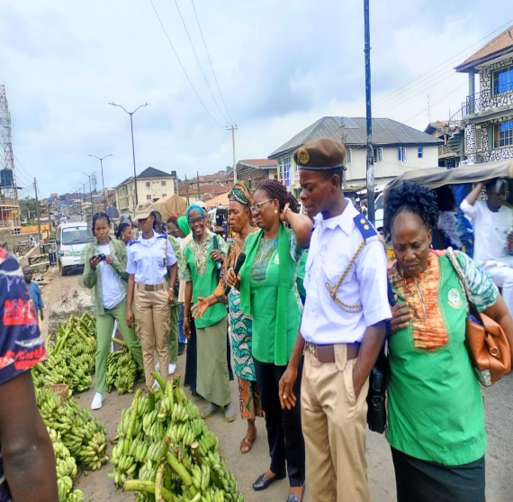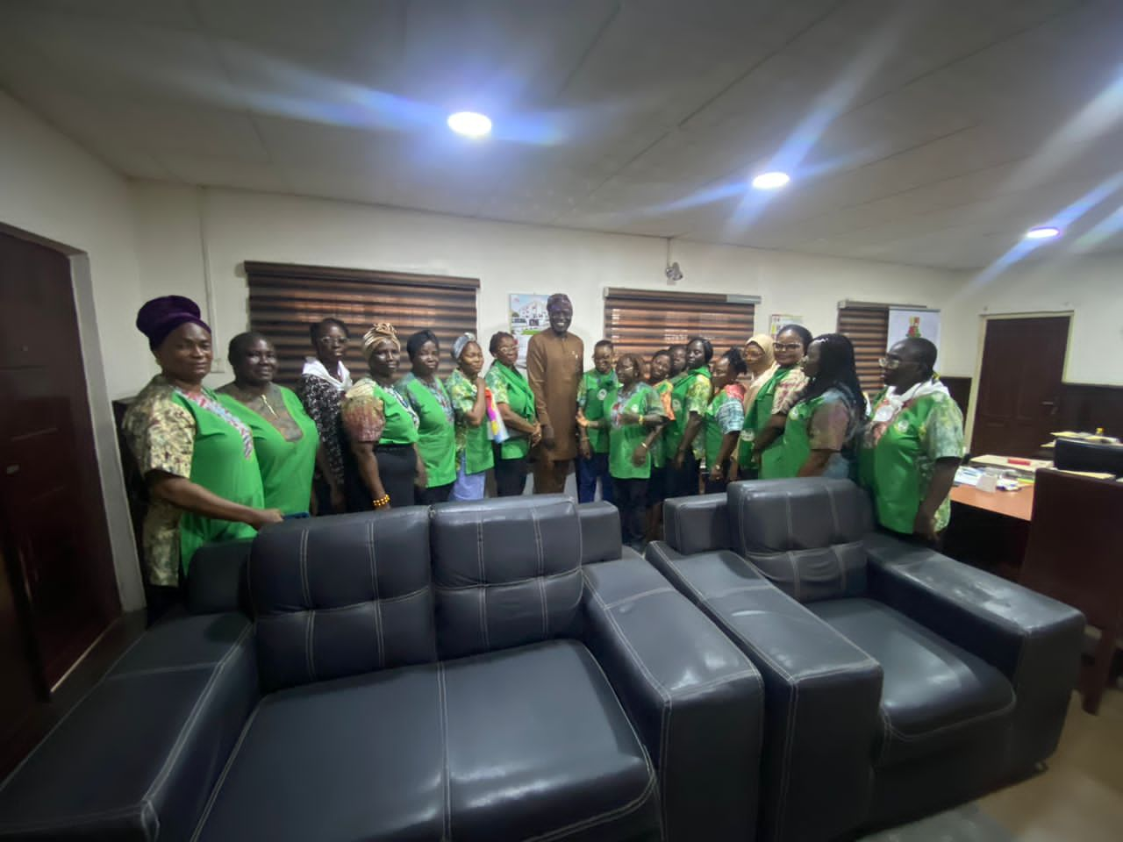

Visitation to the Honourable Commissioner for Lands, Housing and Urban Development.Oyo State.

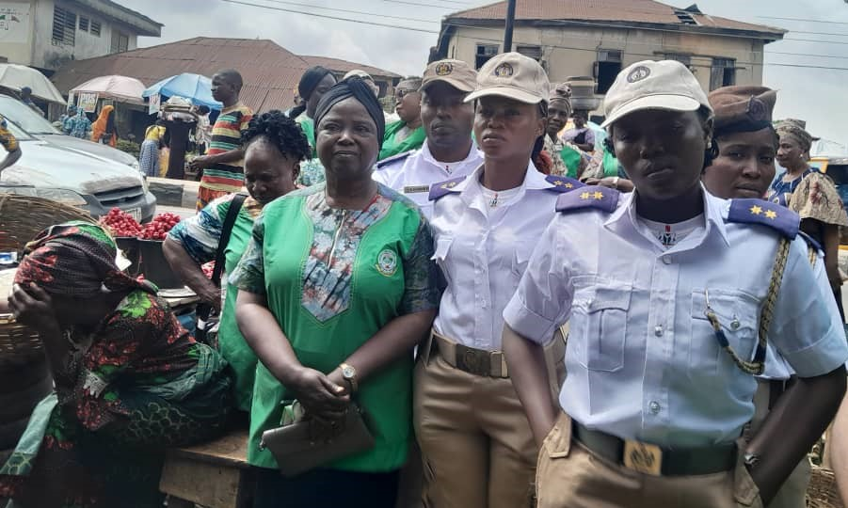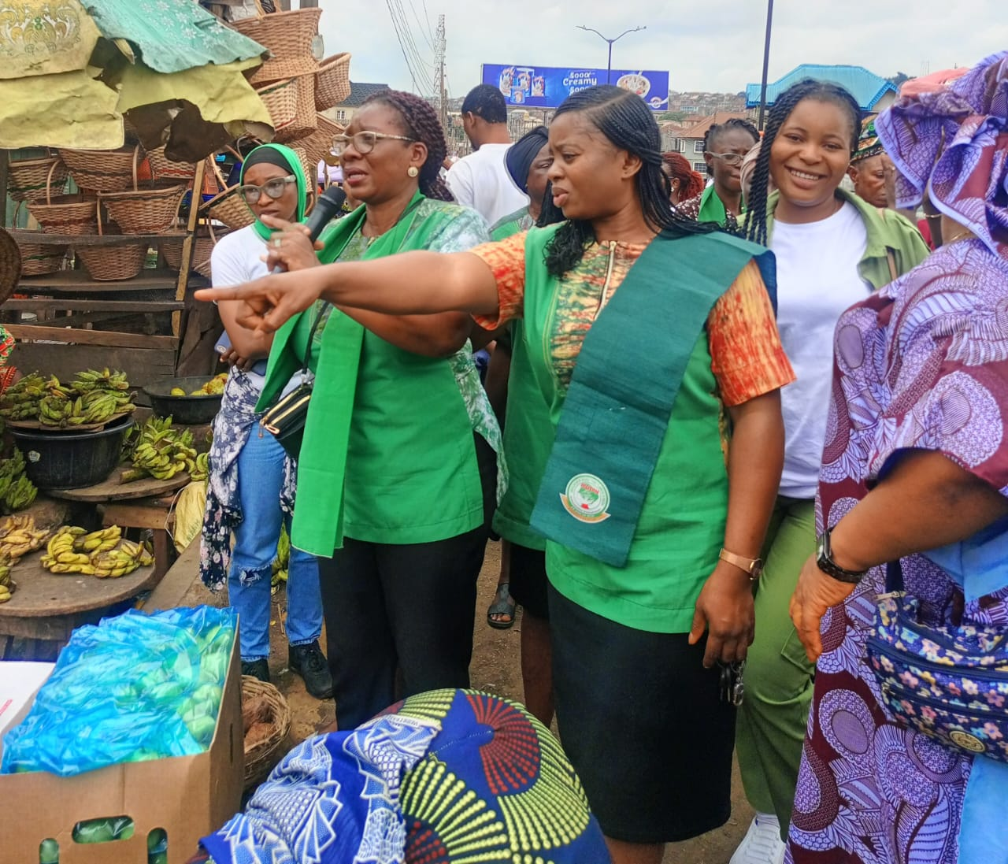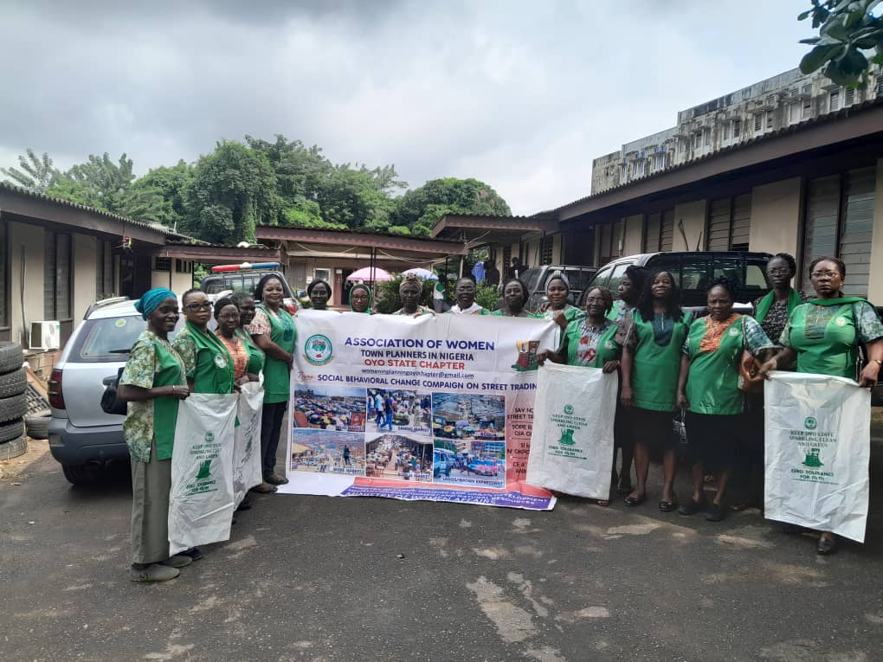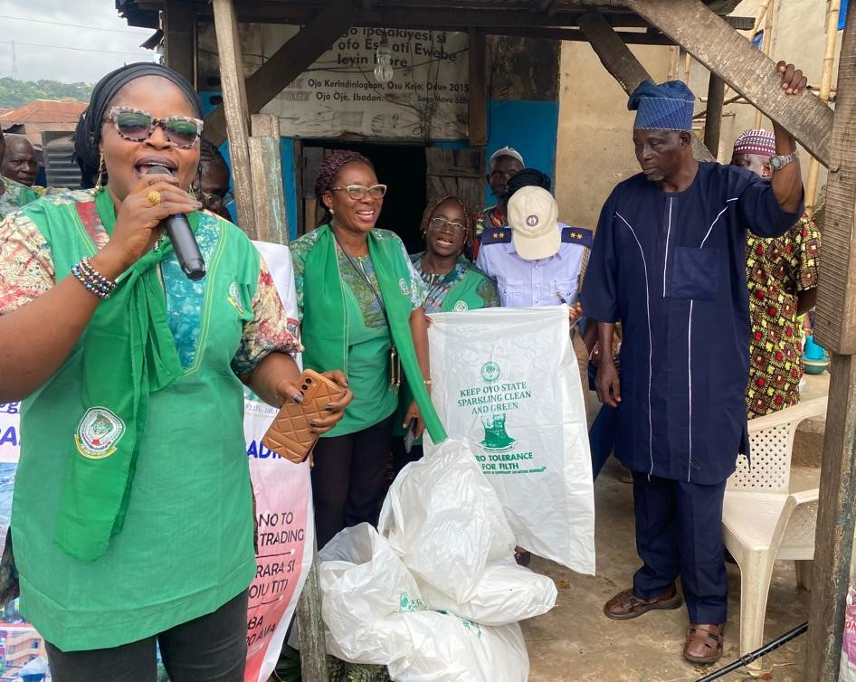

Sentizaitation at Oje fruits Market on street trading and waste management

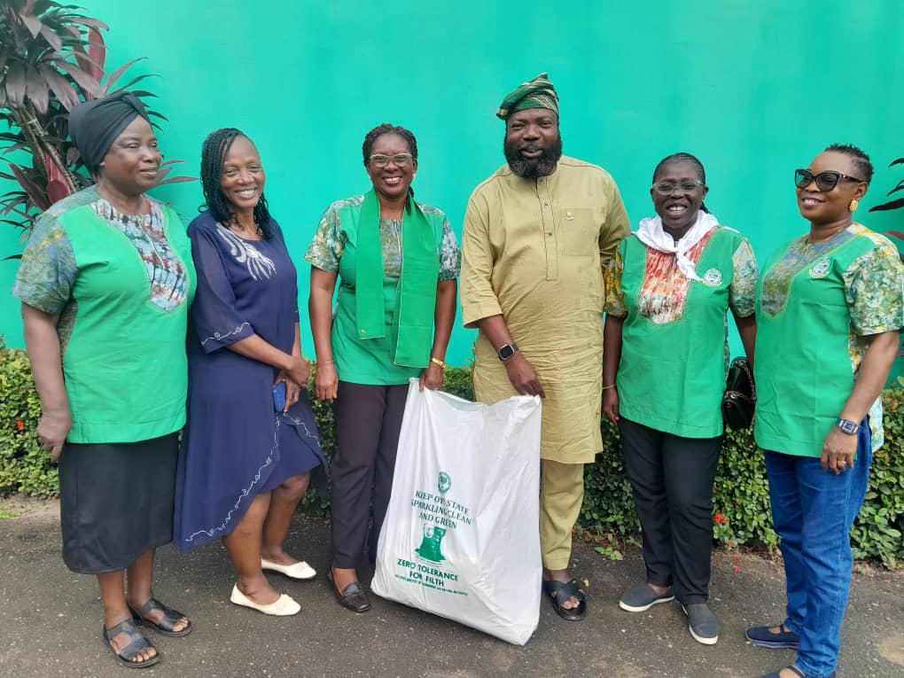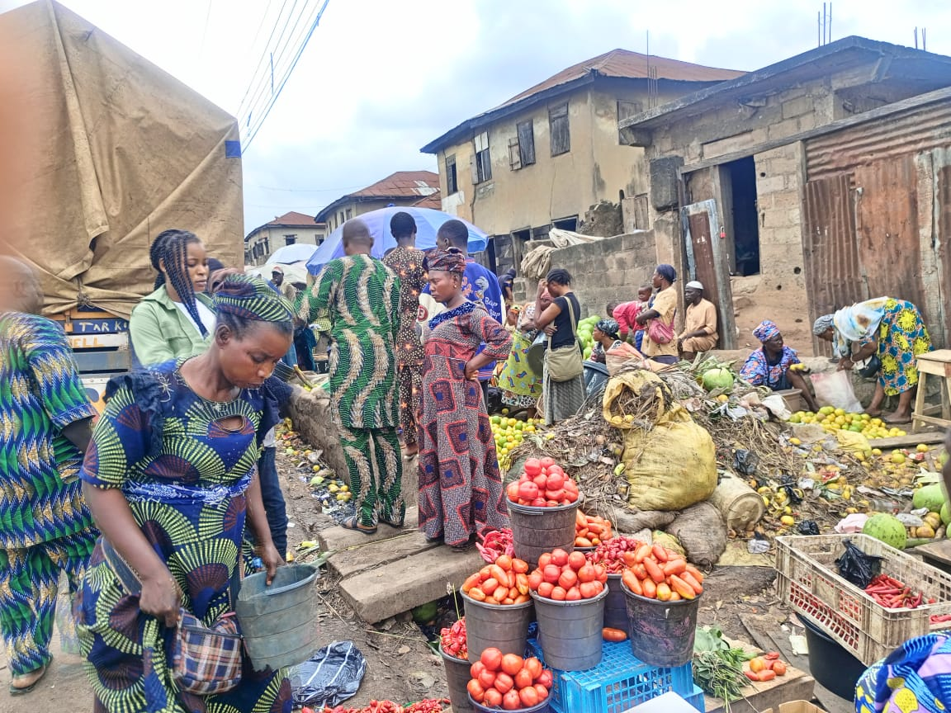

Commissioner for Ministry of Environment and Natural Recourses at presentation of some waste disposal bags donated by the Association of Women Town Planners,Nigeria.Oyo State Chapter

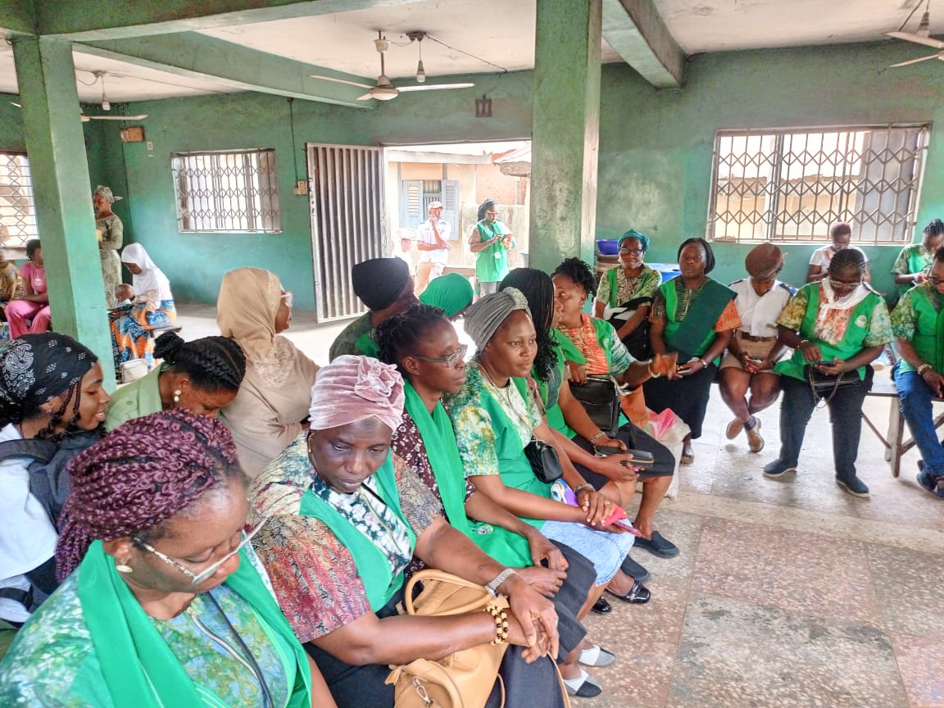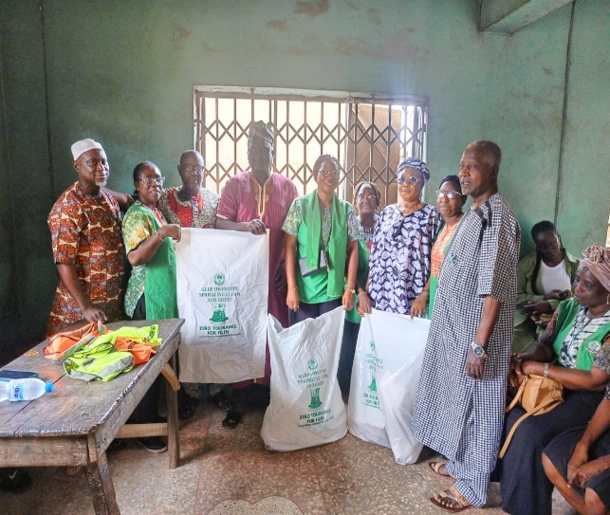

Meeting and presentation of waste bags to Market heads